

Assignment Cover Sheet

advance programming

To be completed electronically by the student and submitted with each piece of work. Please upload this completed cover sheet via Turnitin.

Assignment Title:

Tutor: Muhammad Ali
Student Number: 0324097
Date of Submission: 06/11/2025
Details of your submission: Advanced programming assessment

For an online submission, please enter the URL of where your project files can be accessed (e.g. Google Drive). If a physical artefact, please provide further details on how this project has been submitted to tutors.
Advance Programming Assessment
https://drive.google.com/drive/folders/14KPcX51hVz7XZGSsENO0tp85usx3tgm8

In submitting this assignment, I am confirming that I have read and understood the regulations for assessment, and I am aware of the seriousness with which the institute regards unfair practice.
Please see the academic Unfair Practice Policy for details.

Signed: Date: 06/11/2025

Exercise 1: Math Quiz
Code:
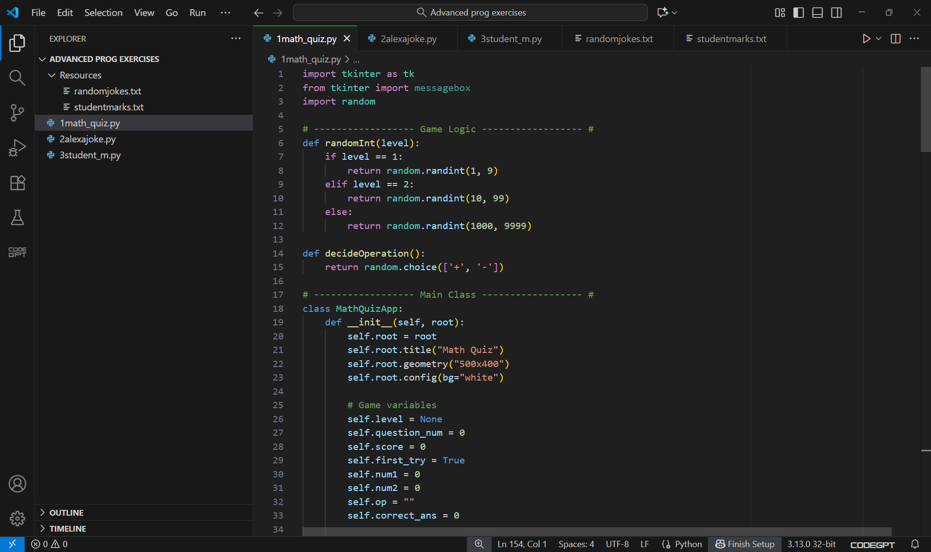
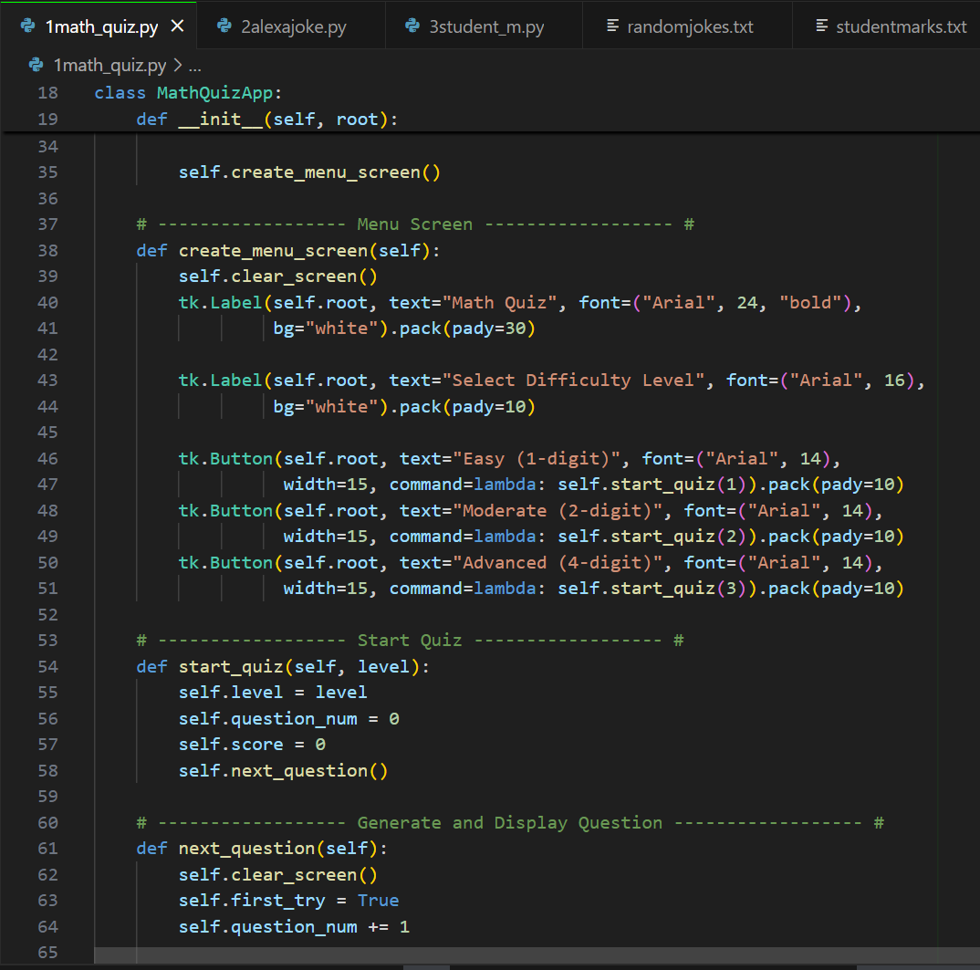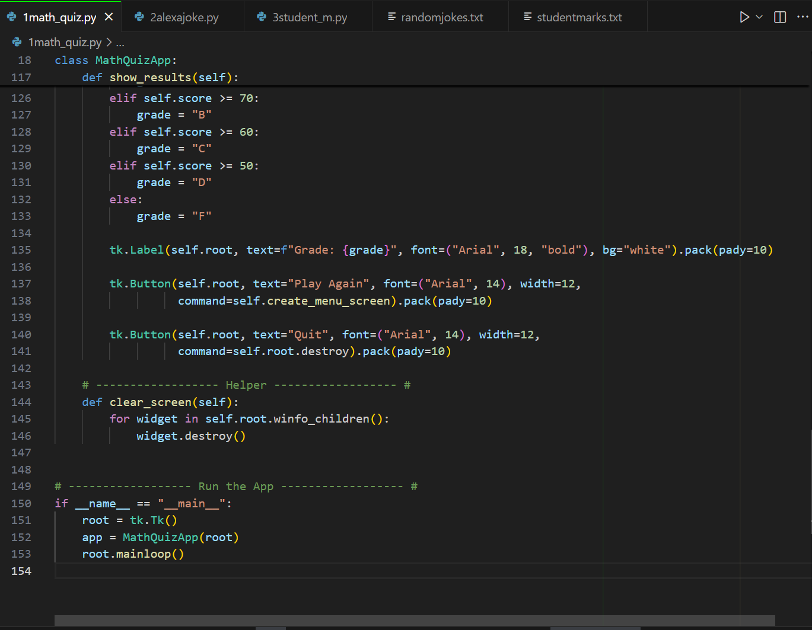

Output:
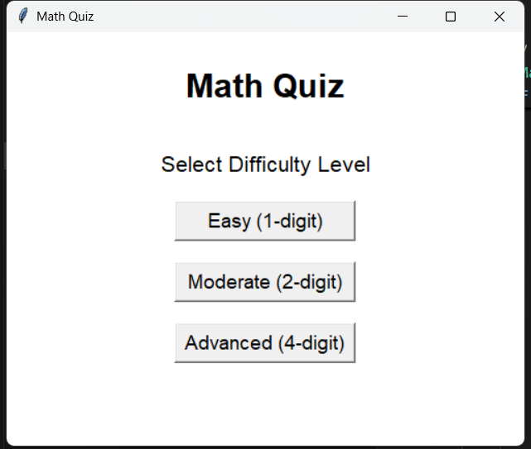
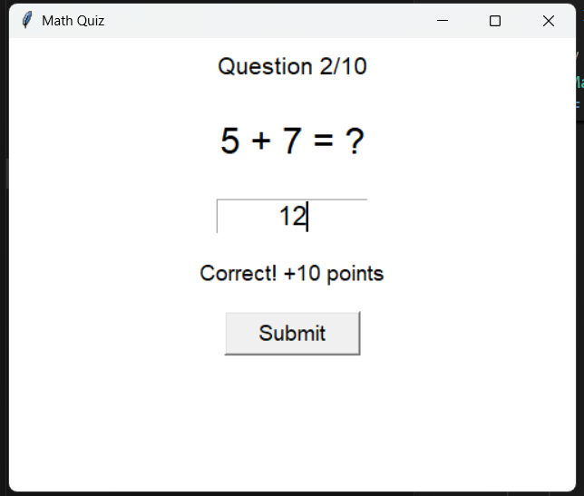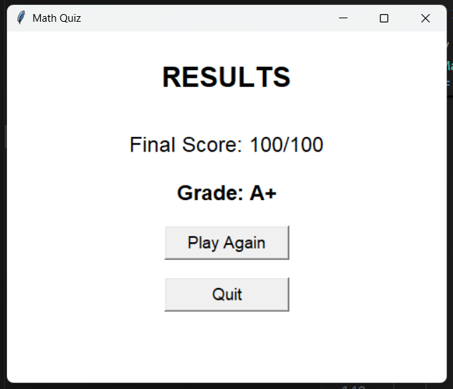

EXERCISE 2: Alexa Joke Teller
Code:
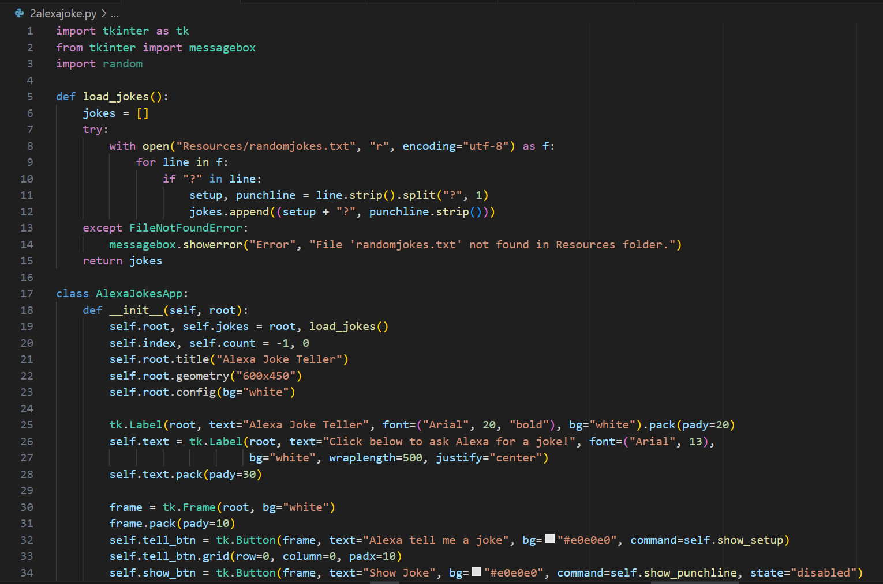
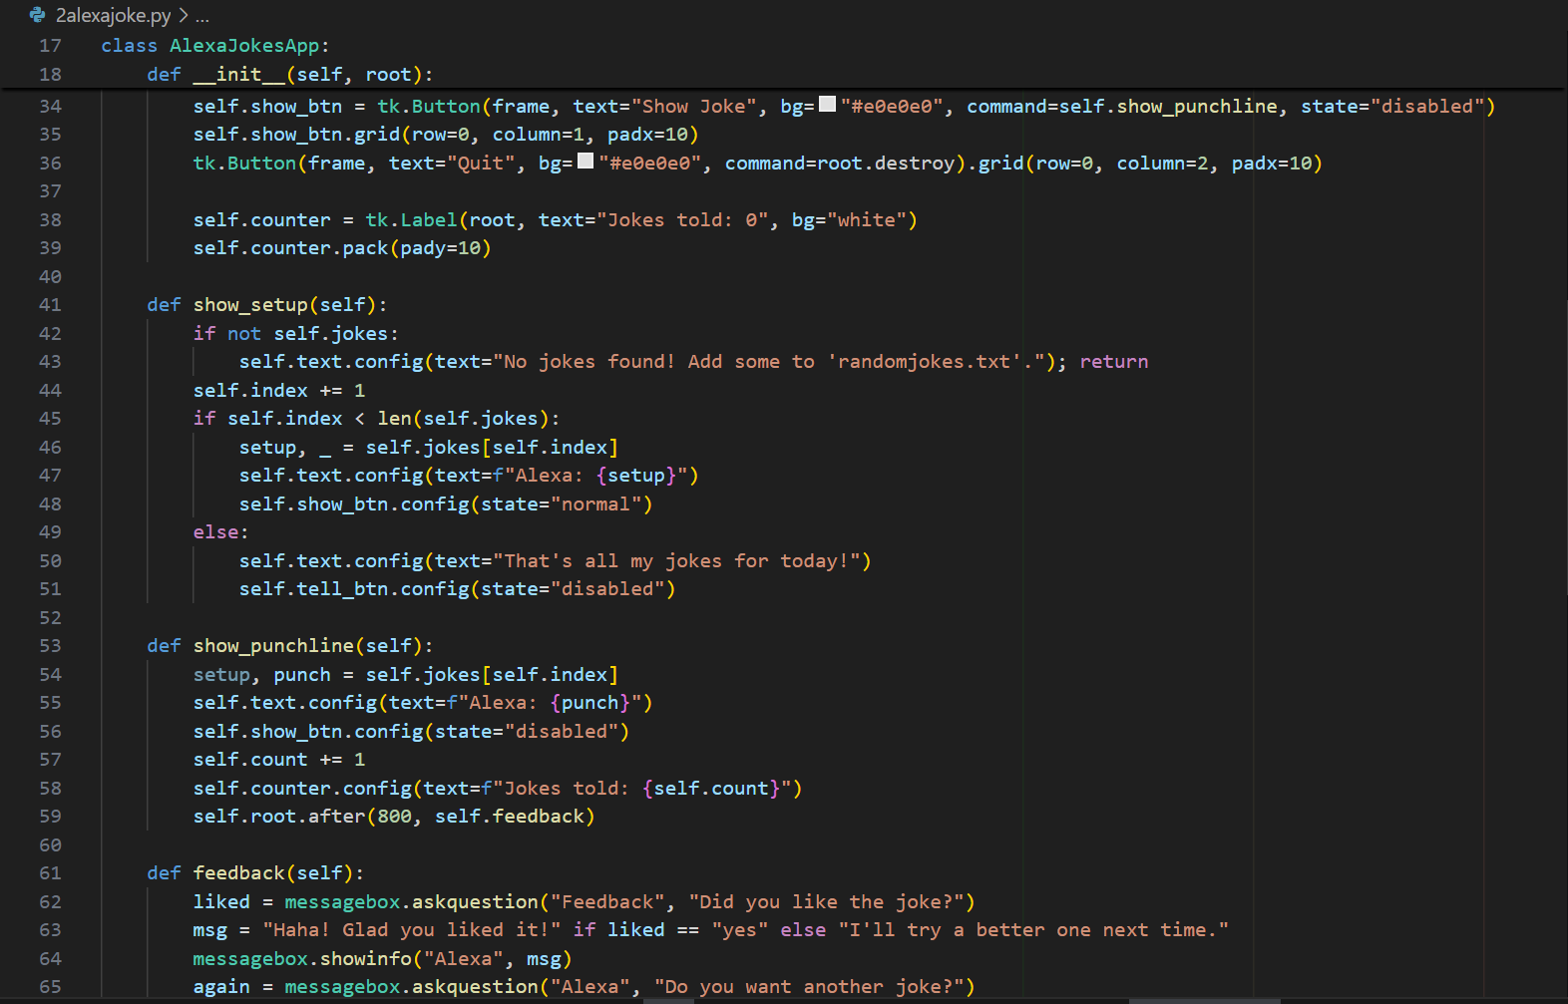
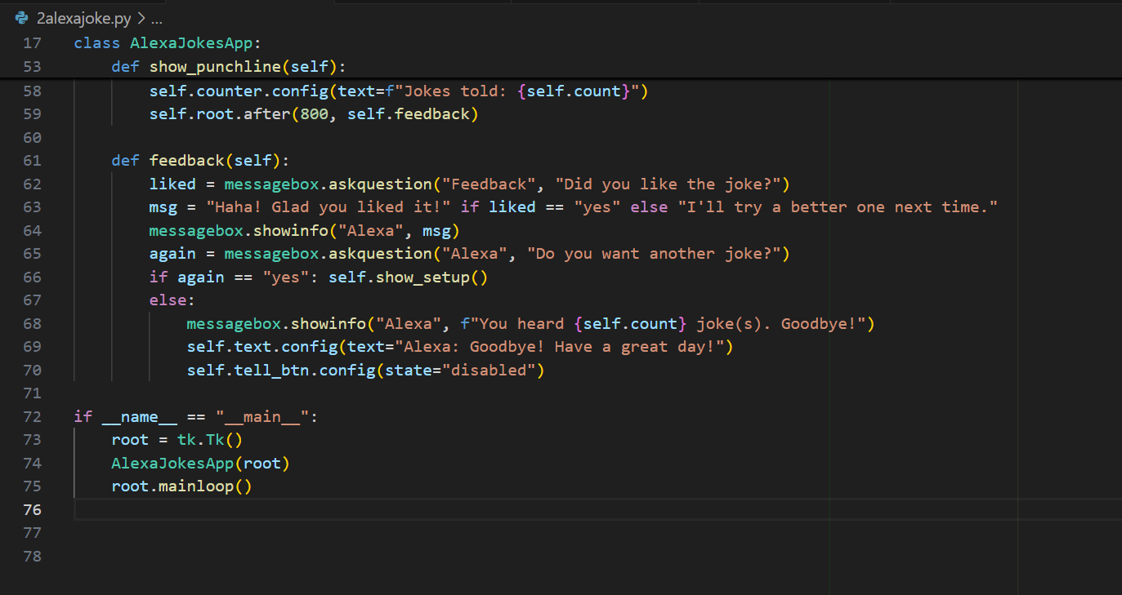
Output:
randomjokes.txt file saved in resource folder,
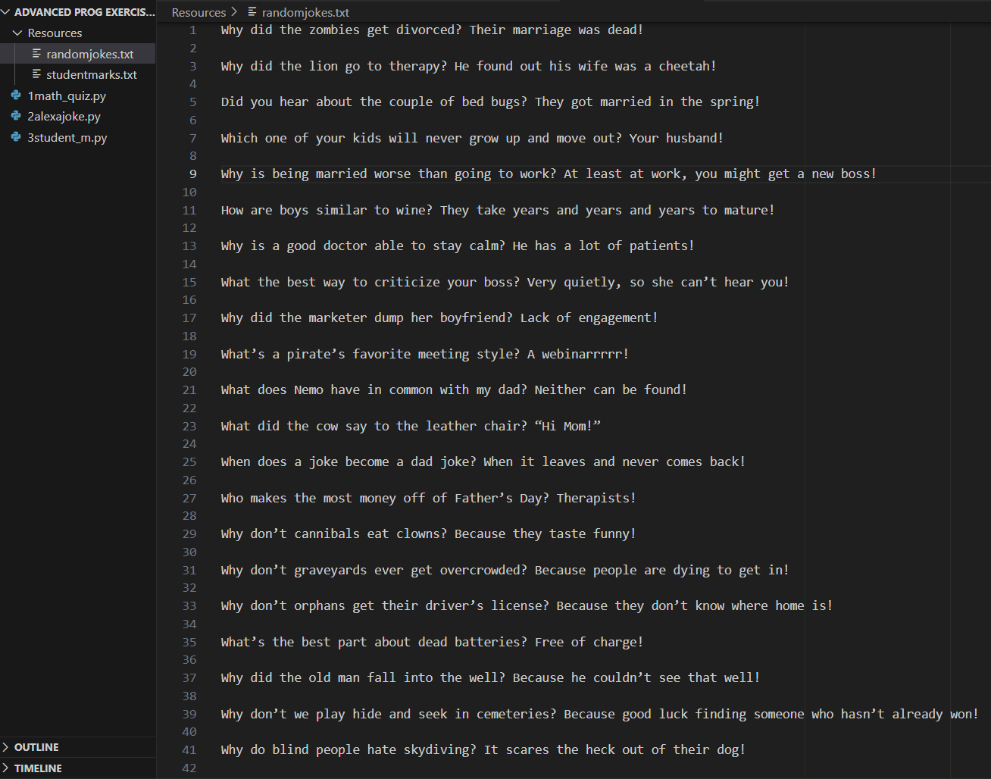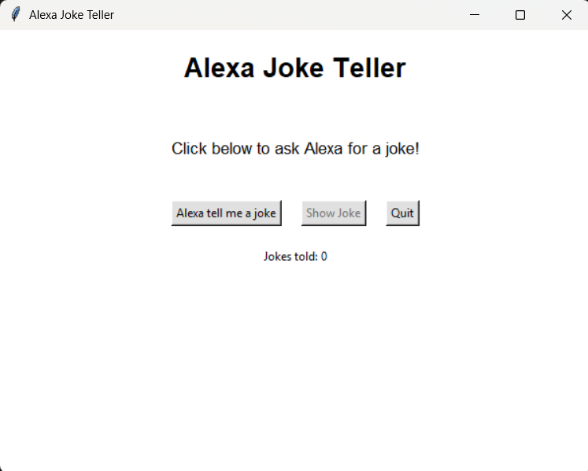
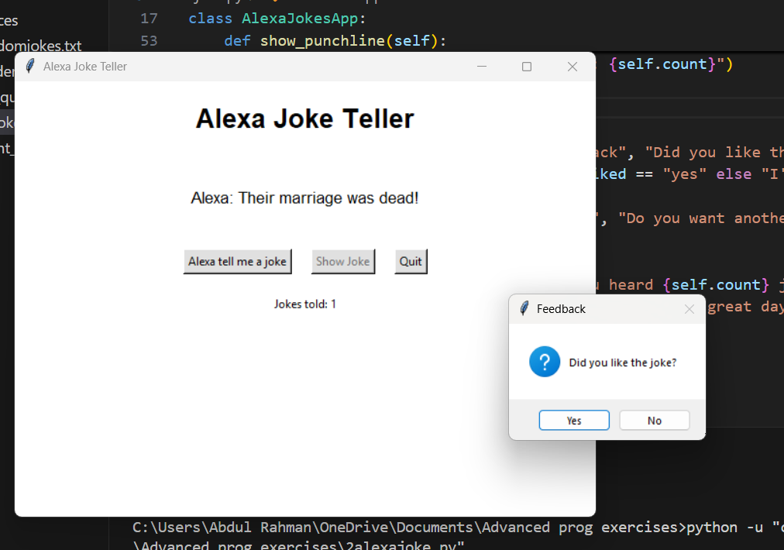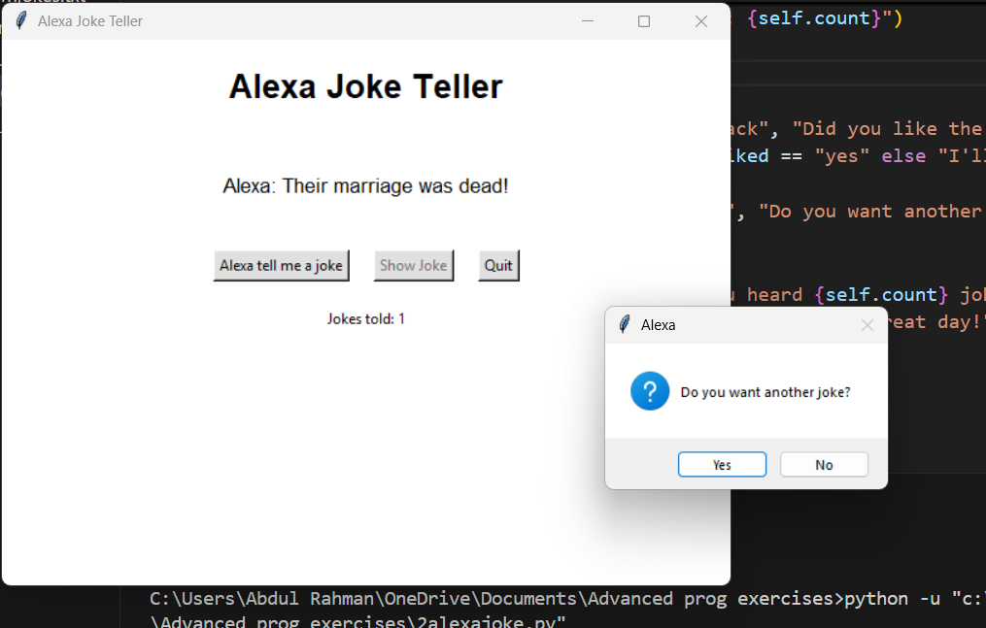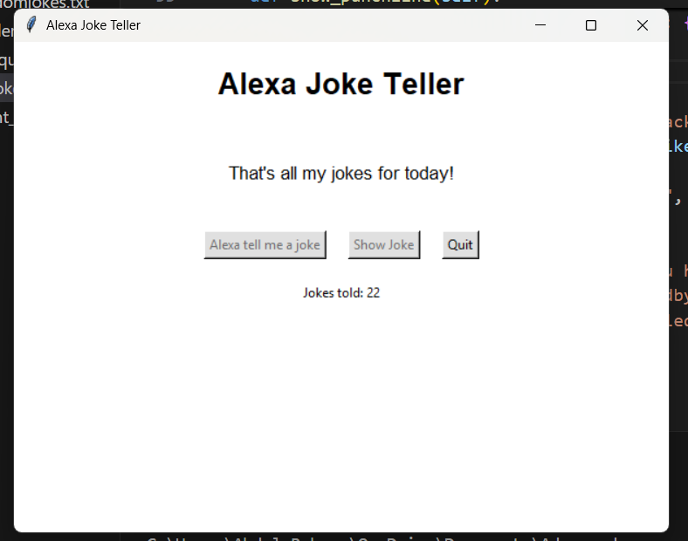

Exercise 3: Student Manager
Code: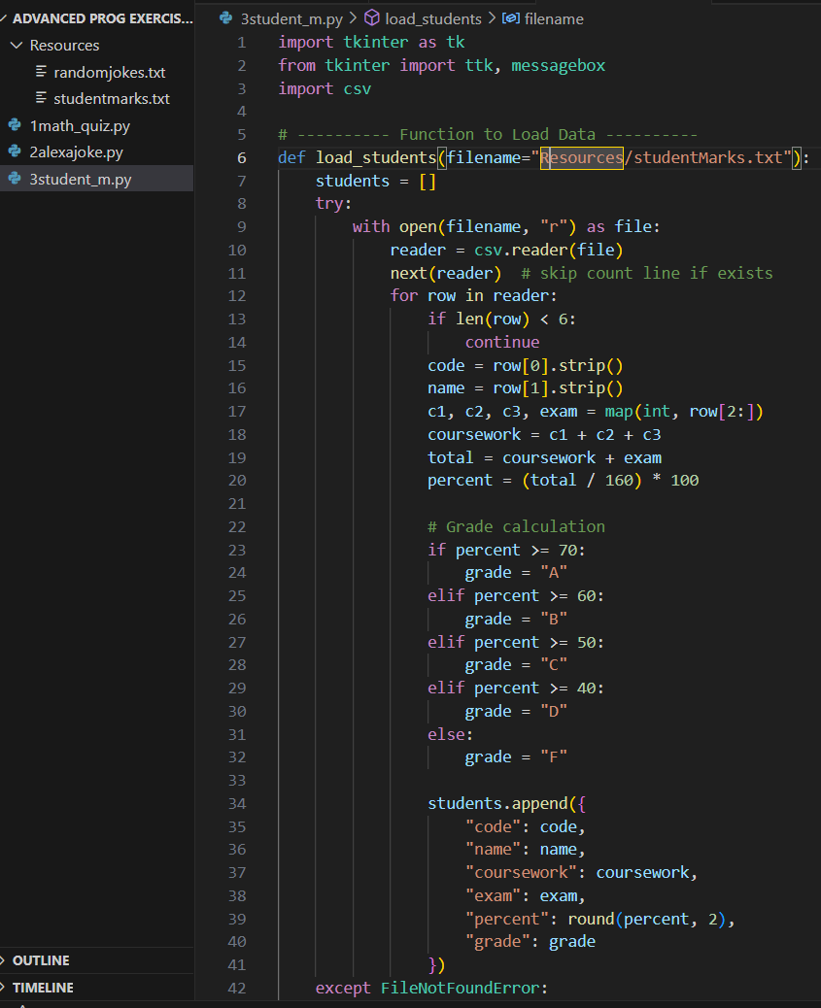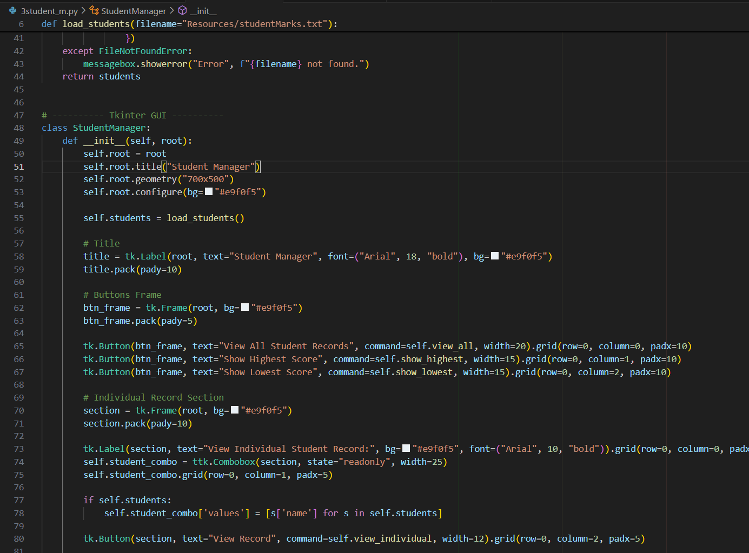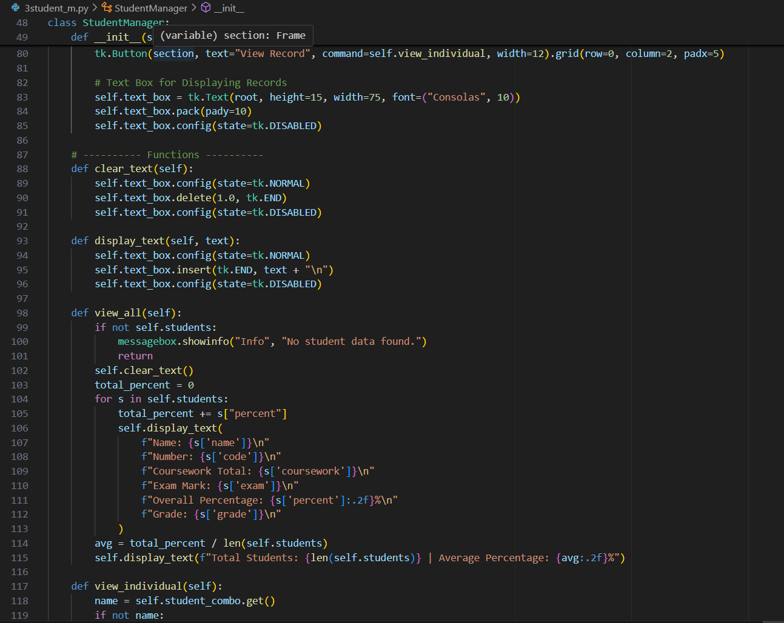
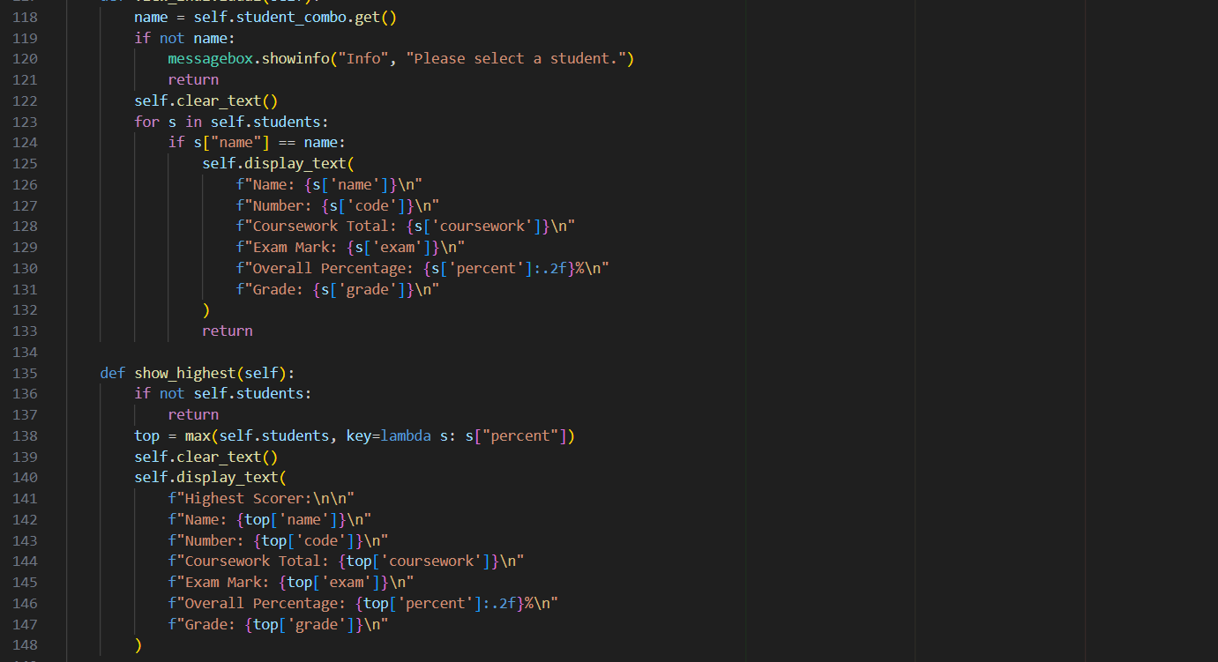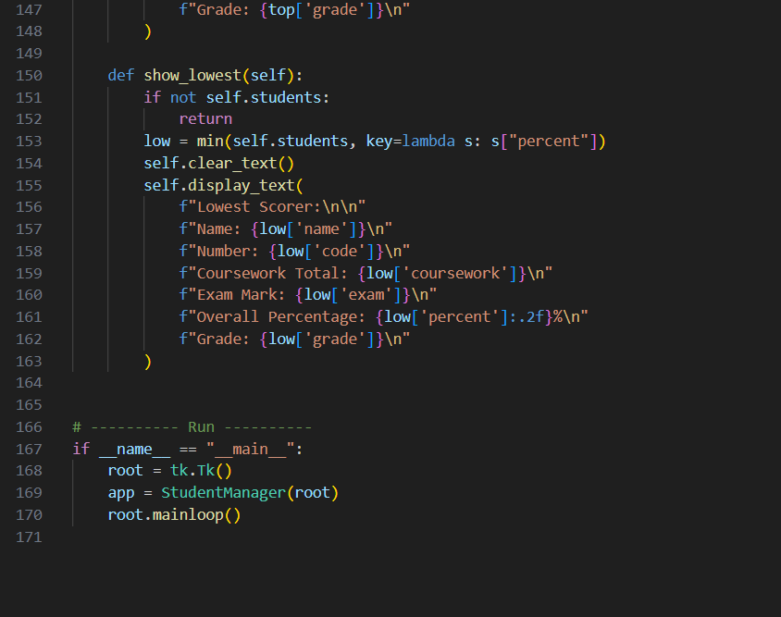
Output:
studentMarks.txt file saved in resource folder,
